Physical Science
Name ___________________________________

Drag force

The force of air resistance, or drag force, has a major impact on fuel costs, whether traveling over the road or through the air. Below, we study air resistance using a parachute, and then use the results to compare the fuel consumption of a car and Boeing 747.

Data Collection

Experimental Logger Pro (*.cmbl) files are located in the “parachute” folder. Each file contains a table, graph, and a movie of a parachute drop. The parachute drops differ only in the extra load on the parachute, giving in grams in the file name. Double click any one of these files, and watch the video. Note that as parachute falls, the

- speed of the parachute increases at first
- downward force on parachute by gravity (weight force) stays the same
- upward force on the parachute by air (drag force) increases

- In the space below, model the forces on the parachute as it falls. Ignore all forces except the weight force and drag force. Provide an ON-BY force diagram for the following four points in the motion:

(1) just after the drop
(2) on the descent, but before the forces balance
(3) when the forces just balance
(4) after the forces balance, but before the parachute strikes the ground

- Describe how the parachute speed changes as the parachute falls.

- Below is a screen capture from one the Logger Pro experimental files. The motion is of the parachute represented by a motion map of dots (in the video), with a position-time graph, and a velocity-time graph.

- In these representations, how can one tell that the velocity of descent is constant? (This is called the terminal velocity of the parachute.)

- According to the motion graphs (at the right), what is the approximate terminal velocity of the parachute?

- What is the relationship between the weight force and drag force at terminal velocity. Write this expression in terms of the acceleration of gravity (g).

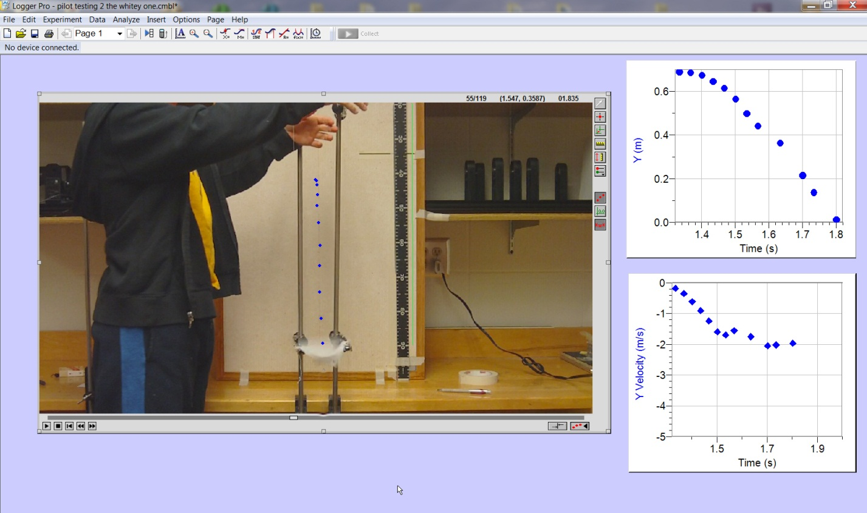
Figure. Screen capture from a Logger Pro experimental file for a parachute drop.

motion dots
- Use the Logger Pro (*.cmbl) files to complete the following table. Note: The mass of the parachute, without extra load, is 9.93 grams. The mass of the load is shown on the whiteboard in the video. To measure the terminal velocity of the parachute, mark the top center of the white parachute in each frame, and fit the last three data points to a line. Close each file after you are finished with it. (If prompted, do not save changes to this file.)

Mass of  load (g) | Total  mass (g) | Total  mass (kg) | Total weight of parachute (N) | Terminal velocity (m/s)

- In a separate blank Logger Pro file, graph the total weight of the parachute (W) versus the terminal velocity (v) (the grayed out columns above). Below, write down the mathematical relationship between these quantities. Hint: Graph velocity squared (v²) on the vertical axis, and weight (W) on the horizontal axis.

- (a) In your own words, how do you think the drag force depends on the terminal velocity? (Refer to 3c.) (b) If the velocity of the parachute doubles, what happens to the drag force?

Follow-Up Activities

An important conclusion of the parachute experiment is that drag force is proportional to the velocity of the object squared (v²). We also expect drag force to be proportional to the cross-sectional area of the object. So, we have

drag force ∝ (area) × (velocity²) × (?).

× ×

- In the open blanks above, write the units below each quantity (Hint: Recall that force has unit of mass × acceleration.) What are the units of the “missing quantity? What does this quantity correspond to?

In general, the amount of fuel necessary to travel from one place to another is directly related to magnitude of drag force; if the drag force is large, the energy lost is large, and therefore the amount of fuel consumed is large. For the remaining items, assume that fuel consumption is proportional to the drag force.

- Write the relationship between fuel consumption (F), cross-sectional area (A), air density (d), and vehicle speed (v). (Letters only—do not plug in values.)

- Compare the fuel consumption of a plane and car. Using the above variables (F, A, d, and v), write the ratio of a plane’s consumption and car’s consumption. Use “plane” and “car” as the subscripts. (Again, letters only—do not plug in values.)

- Compute the above ratio. Relative to a car, a Boeing 747 has approximately 10 times the cross-sectional area, flies at altitudes with 1/3 the air density, and travels with speeds approximately 10 times faster.

- Is it more fuel efficient to travel in a plane or a car? (Hint: A Boeing 747 carries approximately 300 passengers.)

- Suppose that you drive from Los-Angeles to New York and back along. The total round-trip distance is about 6000 miles. Assuming 30 miles/gallon and $3/gallon, what is the cost to drive? Based on the above analysis, estimate the cost of the corresponding plane ticket.

